**Practical-4 - Implementation**

**Step 1:** Click on the file **mingwenv** . We will get the following prompt, type **omnetpp** and enter, as below :-

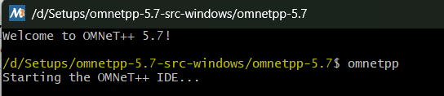

**Step 2:** The omnetpp simulator in now ready with the following user interface

**Step 3:** Click on **inet** folder, then in it click on examples, then on **adhoc** and then on **idealwireless**

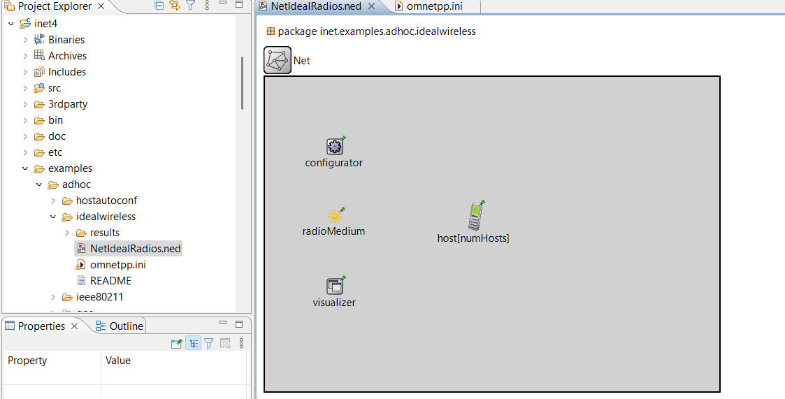

**Step 4:** Now we run the simulation :-

**Step 5:** After running the simulation we get the following :-

Enter number of hosts, say **2**

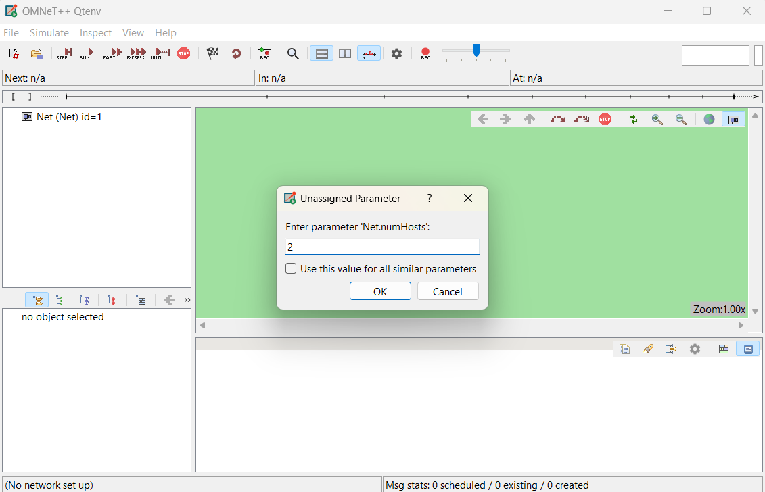

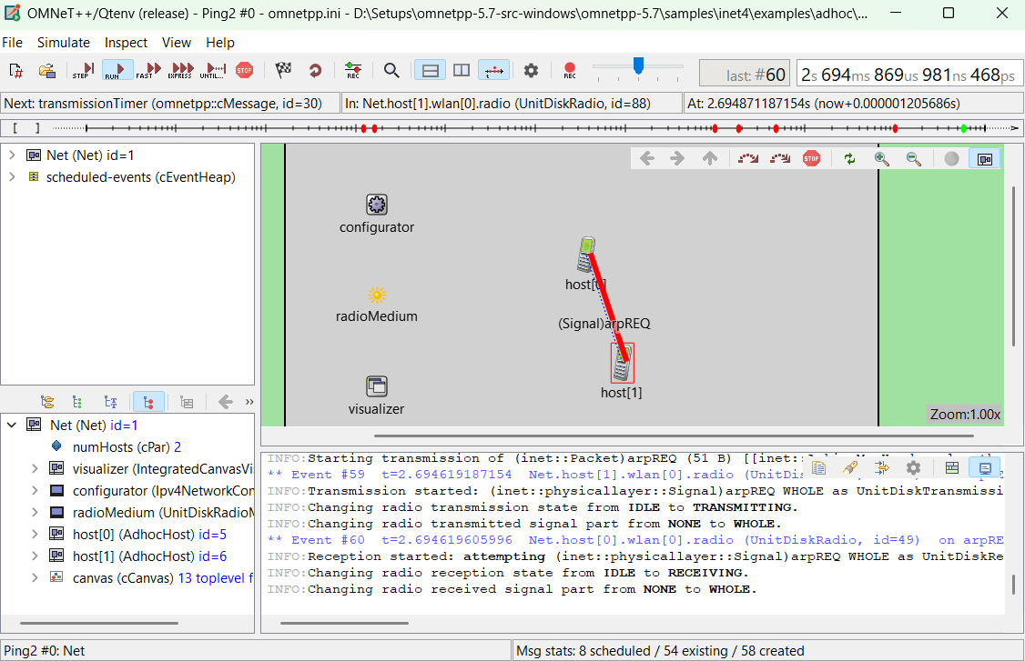

The number of hosts can be increased by the following :- **File > Set Up a Configuration**

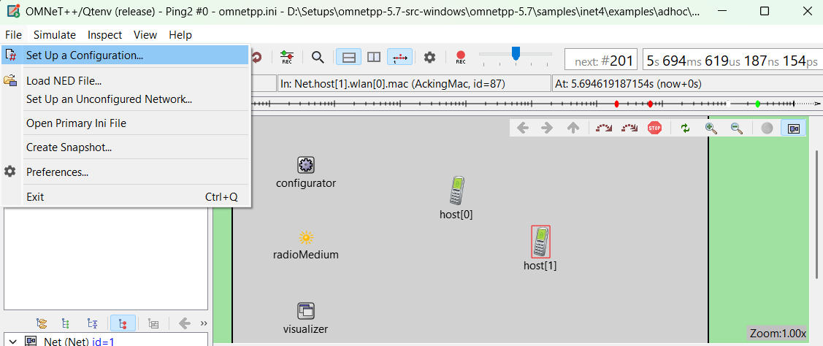

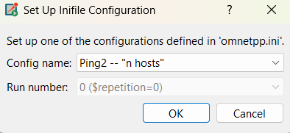

Click **OK**

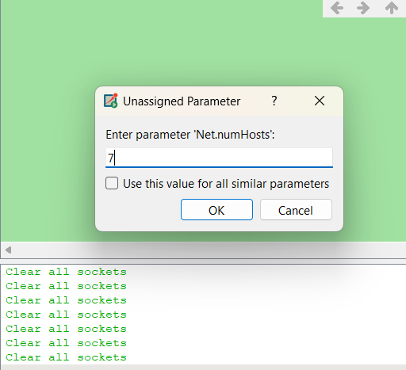

In this we get a dropdown menu, select n host option and enter the required hosts The following simulation has 7 hosts :-

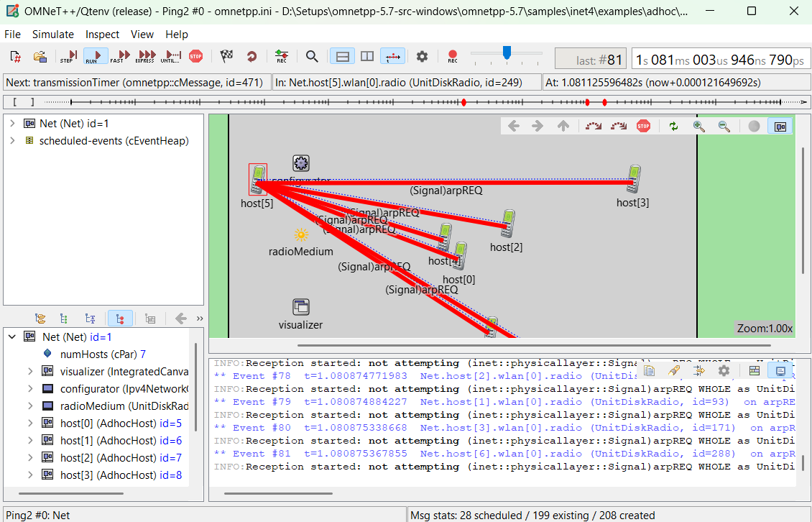

**Practical-5 Implementation**

1. Set up the below configuration by referring to table containing IP Address and serial interfaces (WIC-2T interface for Router1 and Router4)

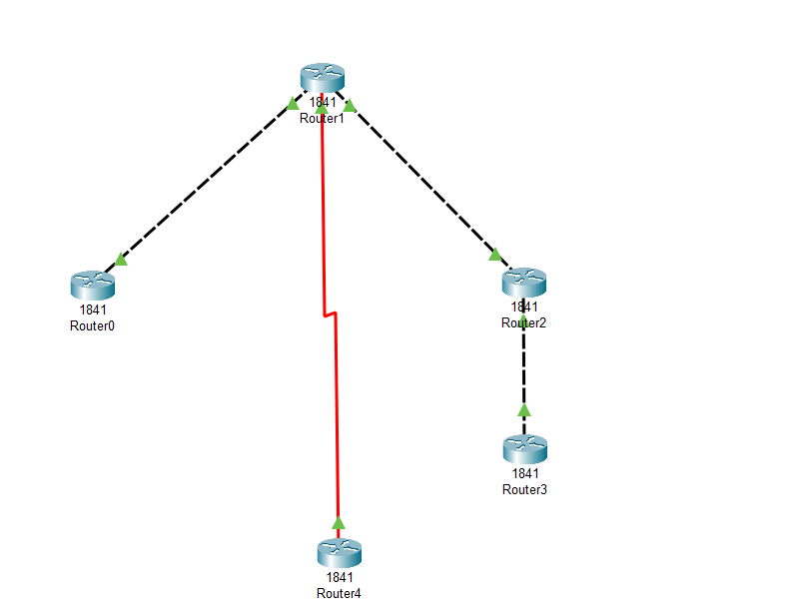

|  |  |  |
| --- | --- | --- |
| **Router** | **Port** | **IP address** |
| Router0 | FastEthernet0/0 | 192.168.1.1 |
| Router1 | FastEthernet0/0 | 192.168.1.2 |
| FastEthernet0/1 | 192.168.2.1 |
| Serial0/1/0 | 192.168.4.1 |
| Router2 | FastEthernet0/0 | 192.168.3.1 |
| FastEthernet0/1 | 192.168.2.2 |
| Router3 | FastEthernet0/0 | 192.168.3.2 |
| Router4 | Serial0/1/0 | 192.168.4.2 |

1. For serial interface for Router1 and Router4 :-

First turn off the router paste it in highlighted box :-  
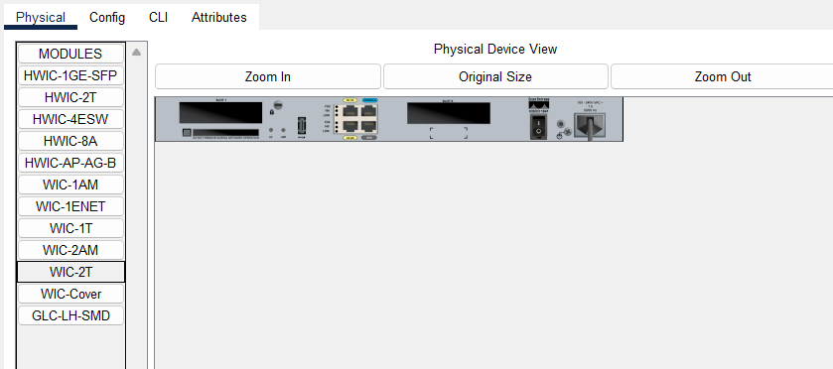

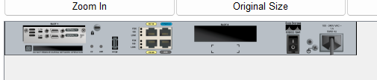

Then turn on both routers and set up their interfaces given above in table.

|  |  |
| --- | --- |
| **Routers** | **RIPs** |
| Router0 | 192.168.1.0 |
| Router1 | 192.168.1.0 |
| 192.168.2.0 |
| 192.168.4.0 |
| Router2 | 192.168.2.0 |
| 192.168.3.0 |
| Router3 | 192.168.3.0 |
| Router4 | 192.168.4.0 |

1. Set Up RIP Routing :-
2. Go to CLI of Router1 :-

Router# **show ip route**

Codes: C - connected, S - static, I - IGRP, R - RIP, M - mobile, B - BGP

D - EIGRP, EX - EIGRP external, O - OSPF, IA - OSPF inter area

N1 - OSPF NSSA external type 1, N2 - OSPF NSSA external type 2

E1 - OSPF external type 1, E2 - OSPF external type 2, E - EGP

i - IS-IS, L1 - IS-IS level-1, L2 - IS-IS level-2, ia - IS-IS inter area

* - candidate default, U - per-user static route, o - ODR

P - periodic downloaded static route

Gateway of last resort is not set

**C 192.168.1.0/24 is directly connected, FastEthernet0/0**

**C 192.168.2.0/24 is directly connected, FastEthernet0/1**

**R 192.168.3.0/24 [120/1] via 192.168.2.2, 00:00:14, FastEthernet0/1**

**C 192.168.4.0/24 is directly connected, Serial0/1/0**

Router#

Therefore, We get the following Routing information from Router1, which is the required output.

**Practical-6-Implementation**

Step 1: Open the Omnet++ software and click on inet4 folder

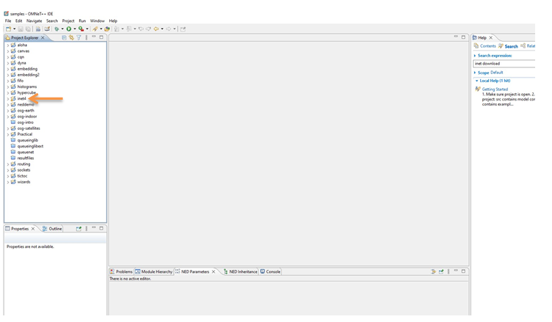

Step 2: Now select the examples folder and then in that folder select manetrouting folder

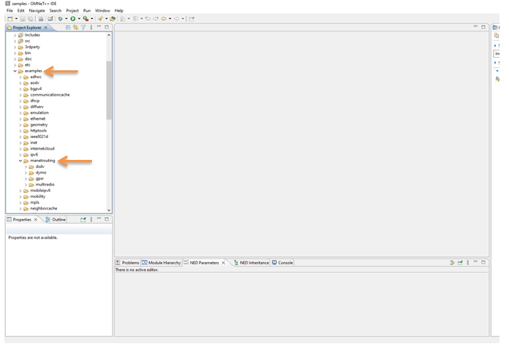

Step 3 : In manetrouting folder click dymo folder and then load the DYMONetwork.ned and omnetpp.ini files by double clicking

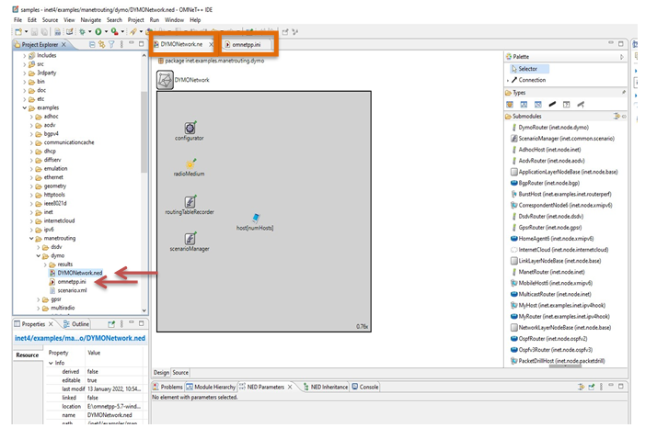

Step 4: Select omnetpp.ini file and click on parameters, we need to add mobility to the nodes. For adding a new parameter click on add button and add the parameter **.mobility.speed which is highlighted below :-

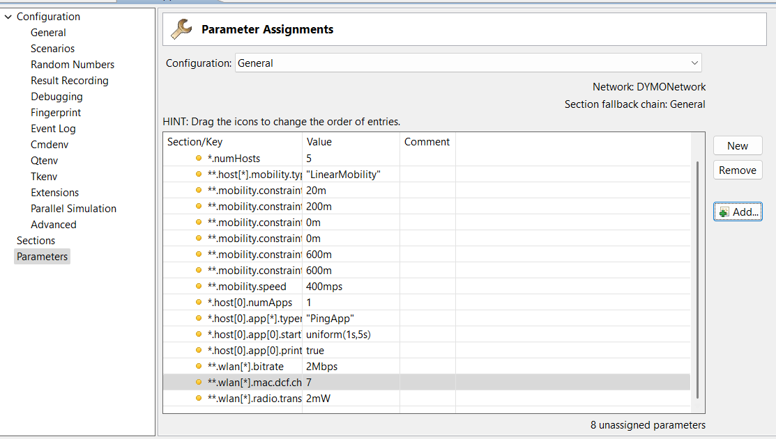

Step 5: Set the value for **.mobility.speed = 400mps

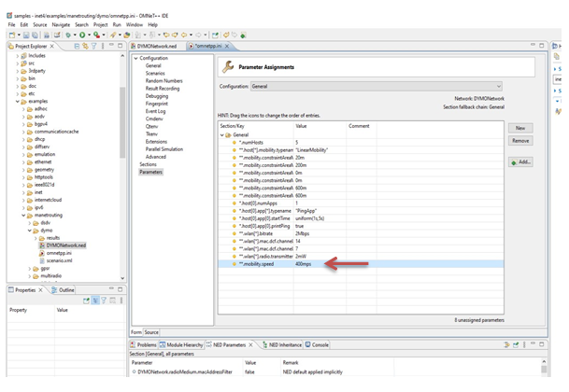

Step 6: Now we run the simulation with 5 mobile hosts forming MANET and get the following output. Since the nodes have mobility, after sometime their positions would change and we get :

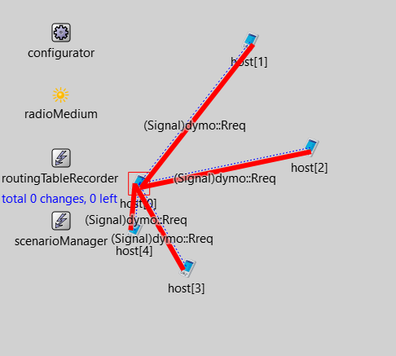

Hence the given MANET has been simulated with 5 hosts

Practical-7-Implementation

**Step 1 :** We Need to Open "Cisco Packet Tracer" software or simulator

**Step 2 :** After Successfully started Go to [Network Devices] select Access Point-PT.

**Step 3 :** Go to [End Devices] select PC, Laptop, Tablet and Smartphone

**Step 4 :** We Need to Connect PC and Laptop also so, Click on PC Off and Remove port and then add **WPC300N**.

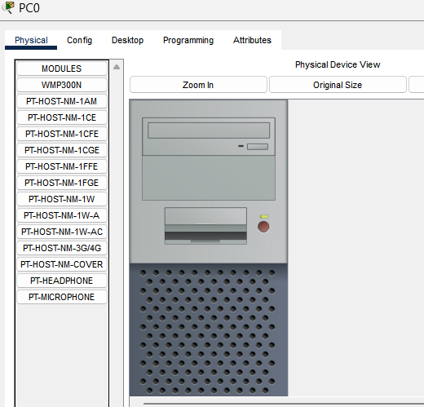

**Step 5 :** Repeat Step 4 for Laptop

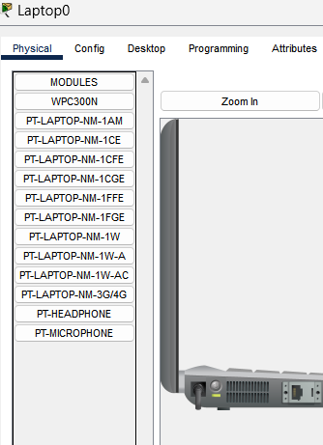

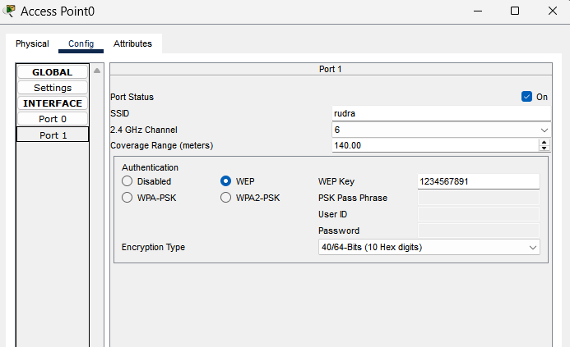**Step 6 :** For Security Purpose we have to add SSID to access point. Click on Access point > Config > Port 1 > Enter SSID and enter WEP key.

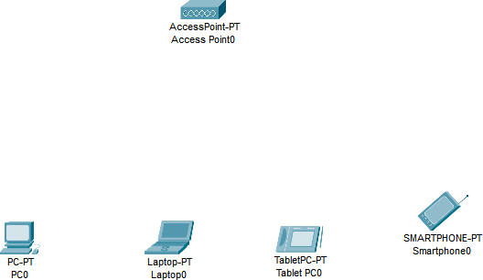Now You can see all the Connection is Disconnected.

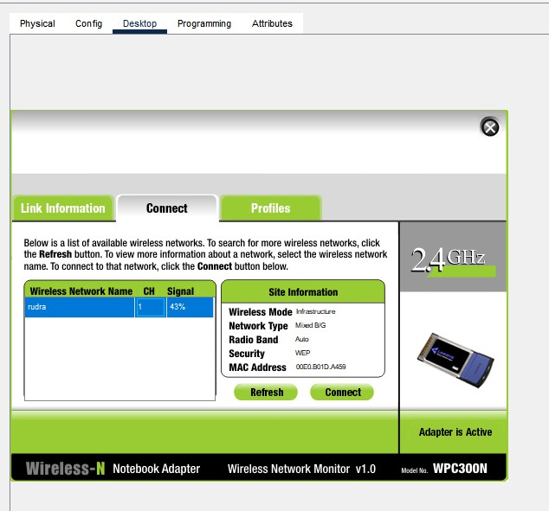**Step 7:** Now Connect PC and laptop using this SSID to access point. Click on PC > Desktop > PC wireless > Connect tab you will see the name of access point appearing , enter WEP Key and click on Connect . Select wireless network

**Step 8:** Repeat the step 7 for laptop also.

**Step 9:** For Tablet and Smartphone. Click on Device > Config > Wireless0 > add SSID and WEP Key.

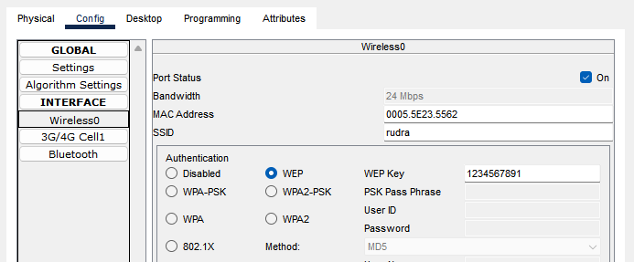

**Step 10** : Now all the Devices are Connected :-

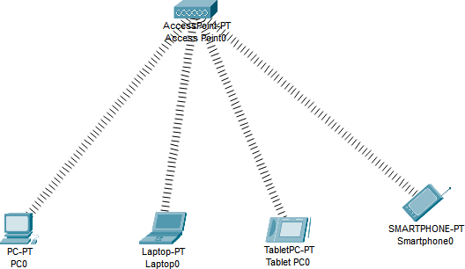

Pract-8-Implementation

**Step 1 :** Setup the below configuration :-

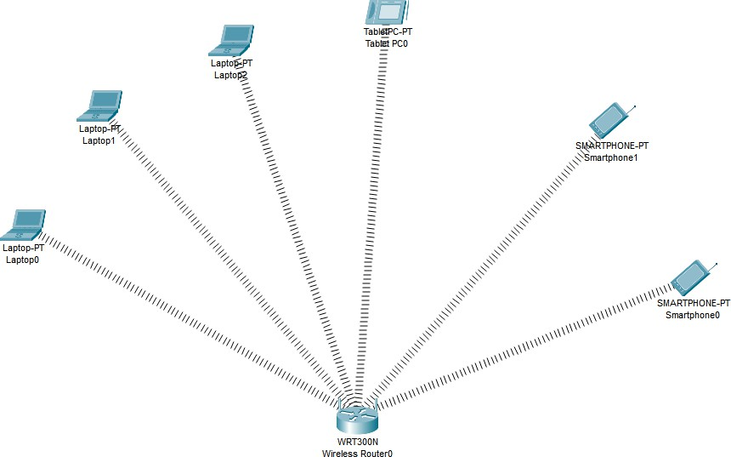

Smart phones and Tablet have a wireless interface by default, while the laptop does not has a wireless interface, we need to add the interface in all the laptops. Adding the wireless interface to each Laptops as follows :

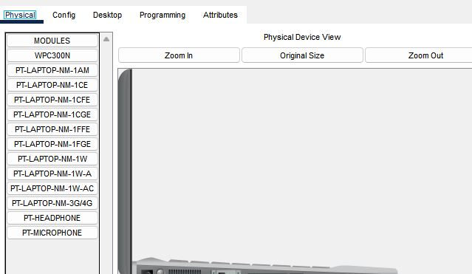

Repeat this **Laptop1** for **Laptop2** as well:

**Step 2 :** Suppose we don’t want Laptop0 , Tablet0 and Smartphone0 to access services , so Copy their MAC address. Click on Device > Config > Wireless0 > Select their MAC Address and copy it.

**Step 3** : Following table shows their MAC addresses :-

|  |  |  |
| --- | --- | --- |
| Devices | MAC Address | Converted MAC Addresses |
| Tablet0 | 0002.1770.D68E | 00:02:17:70:D6:8E |
| Smartphone0 | 0003.E4EA.A000 | 00:03:E4:EA:A0:00 |
| Laptop0 | 0006.2A1E.C521 | 00:06:2A:1E:C5:21 |

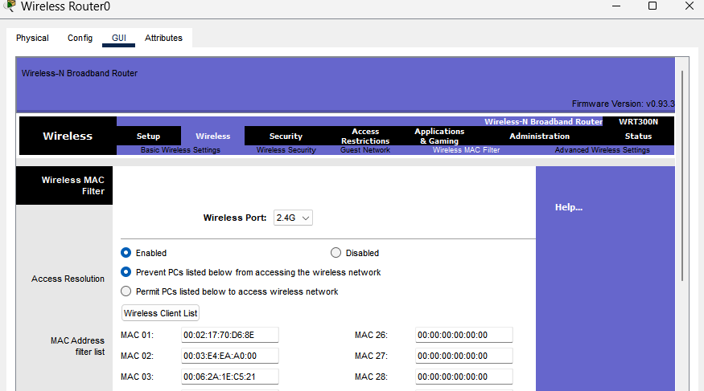**Step 4 :** Now we add their converted MAC addresses in the wireless MAC filter of the Wireless Router and then use the below options for either allow or deny the Wireless access :-

**Step 5 :** The result so obtained is as shown; the three devices denied any wireless connectivity :-

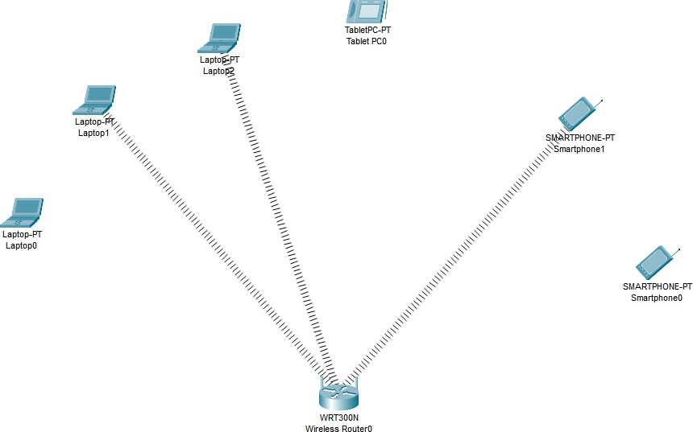

Similarly we can change the setting so that the above devices get wireless connectivity and the remaining devices do not get the wireless connectivity :-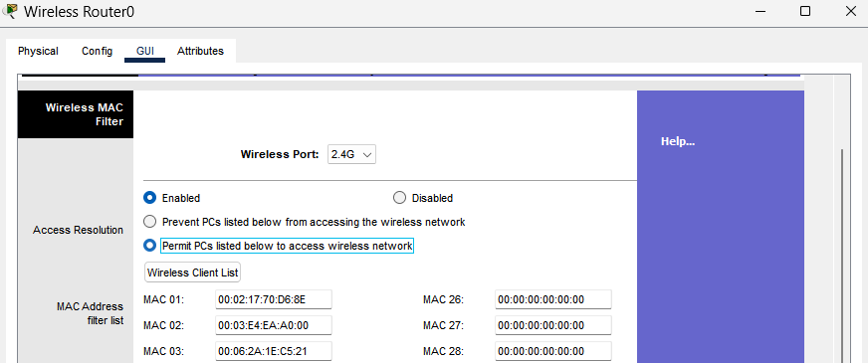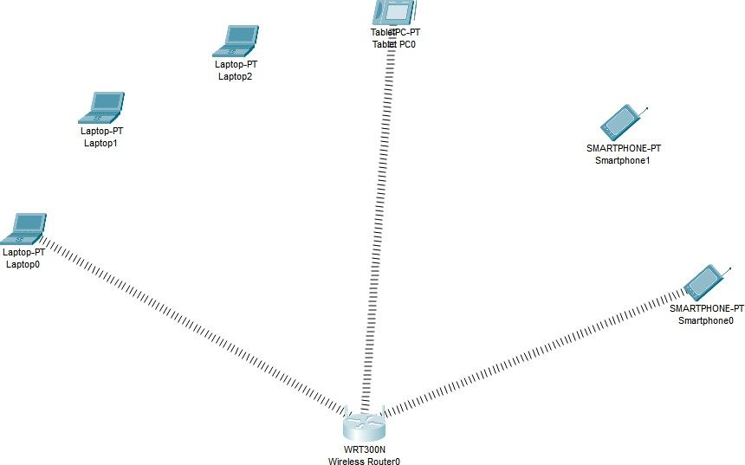

**Practical-9-Implementation**

**Step 1 :-** Setup the below configuration:-

Connect server to Gateway using copper straight-through wire from **FastEthernet0** of server to **Ethernet 1** of HomeGateway0

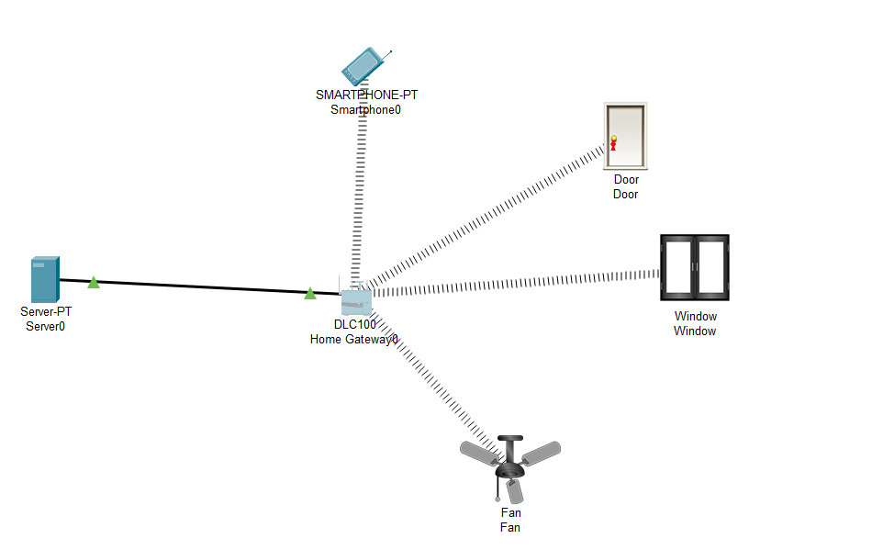

After Setup , Smartphone0 will not connect to HomeGateway because we haven’t setup the SSID name (ID) , We should set the SSID as **HomeGateway** so it can stay connected during any process.

The setup of Smartphone0 ‘s SSID :-

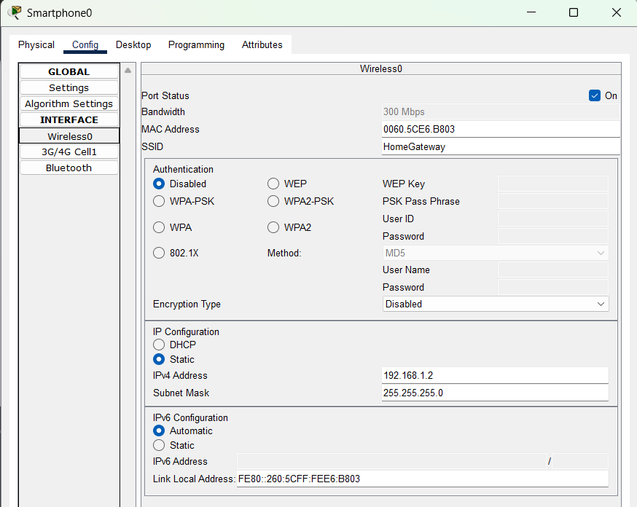

After this we will get the above configuration topology.

**Step 2 :-** The IP addresses are configured below :-

|  |  |
| --- | --- |
| **Devices** | **Static IP Address And Subnet Mask** |
| Server0 | IP Address : 192.168.1.1 |
| Subnet Mask : 255.255.255.0 |
| Smartphone0 | **Wireless0** IP Address : 192.168.1.2 |
| Subnet Mask : 255.255.255.0 |
| Door(IoT) | **Wireless0** IP Address : 192.168.1.3 |
| Subnet Mask : 255.255.255.0 |
| Window(IoT) | **Wireless0** IP Address : 192.168.1.4 |
| Subnet Mask : 255.255.255.0 |
| Fan(IoT) | **Wireless0** IP Address : 192.168.1.5 |
| Subnet Mask : 255.255.255.0 |

**Step 3 :-** Click on Server0 > Services > IoT , Switch on the registration server

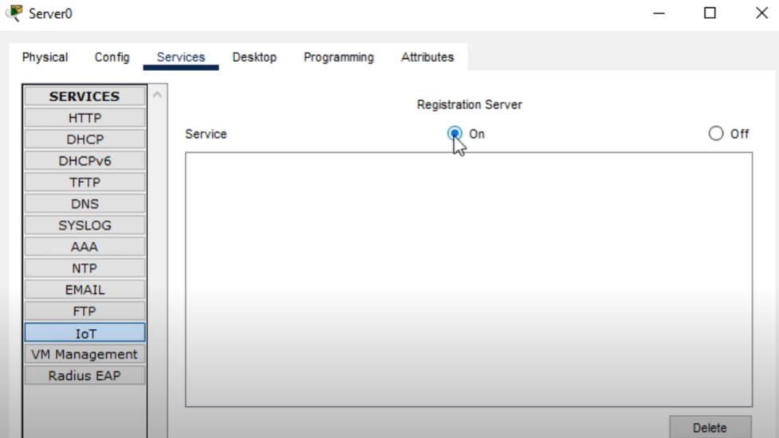

**Step 4 :-** Then switch to Desktop tab > click on Web Browser > enter 192.168.1.1(IP address of Server0) :-  
  
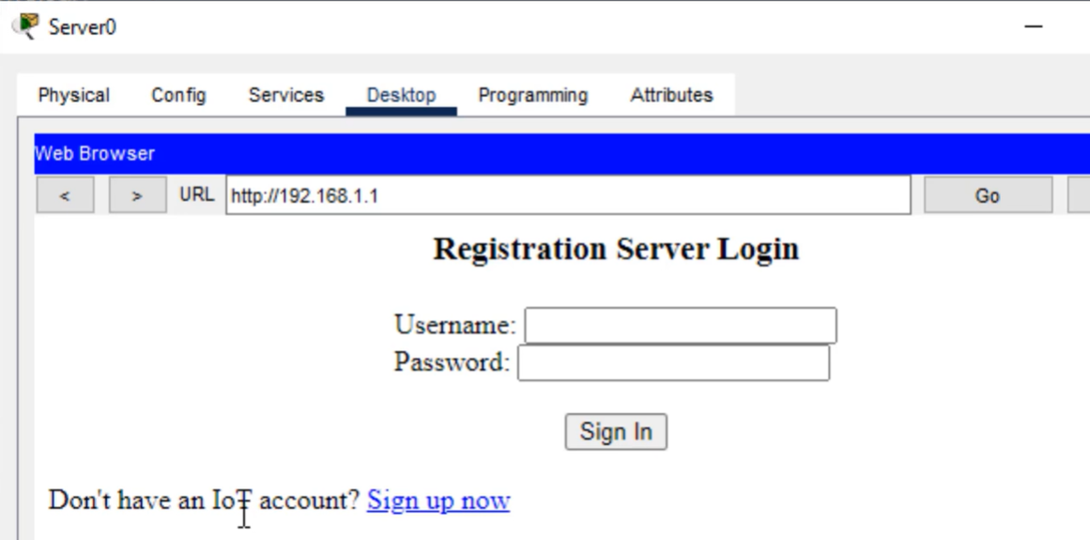

**Step 5 :-** Since we don’t have an account , we should click on **Sign up now**

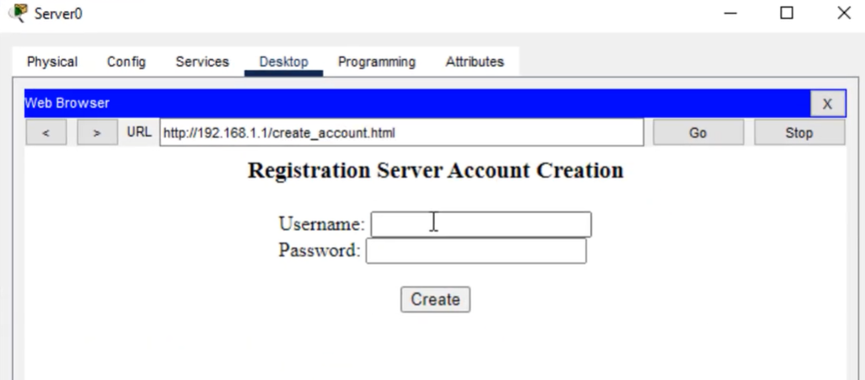

Enter username and password as per your choice :-  
say,

Username :- rudra

Password :- sies

**Step 5 :-** Click on **Create**. The following window will appear :-

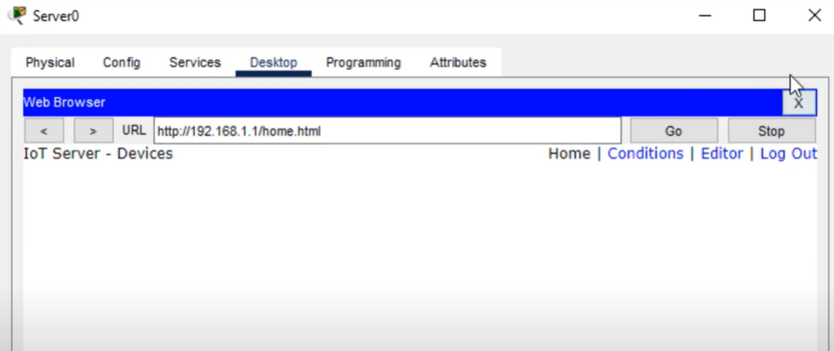

**Step 5 :-** Click On Door > Config Tab > Settings . Under it select IoT Server as Remote Server and mention the credentials and Click on Connect button :-

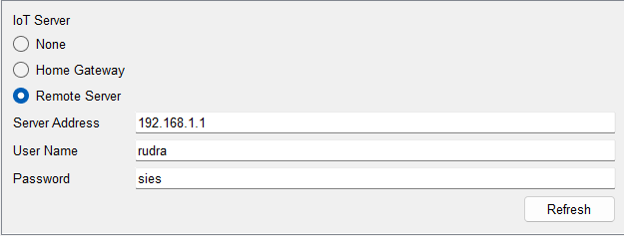

**Step 6 :-** Repeat Step 5 for Window and Fan

**Step 7 :-** Click on Smartphone0 > Desktop > Web Browser . Mention server IP address in URL field :-

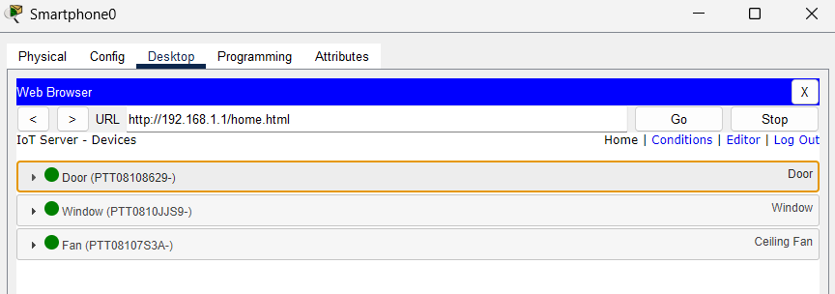

**Step 8 :-** Click on **Conditions**. Then click on **Add** to add condition :-  
  
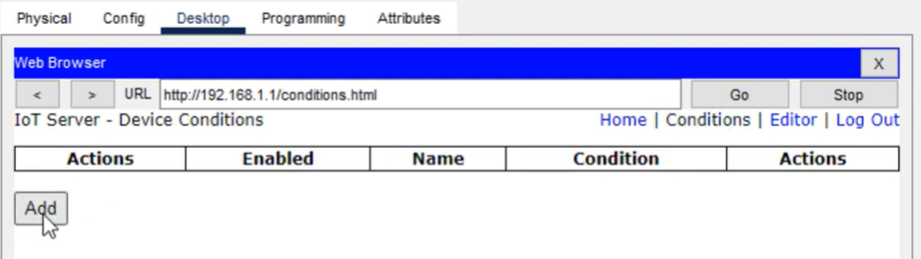

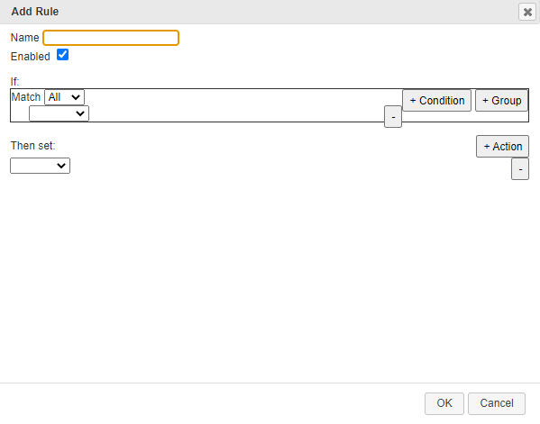

**Step 9 :-** Configure 2 conditions given below :-

1. For door unlock, Rule :-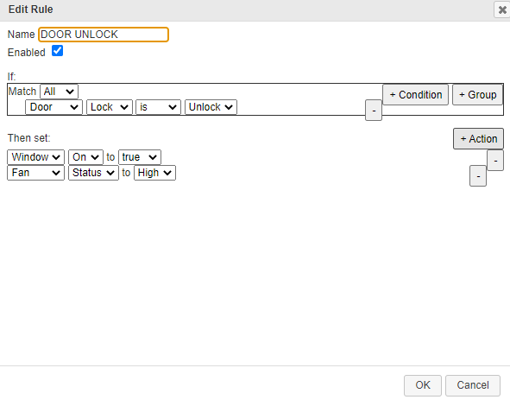
2. For door lock, Rule :-

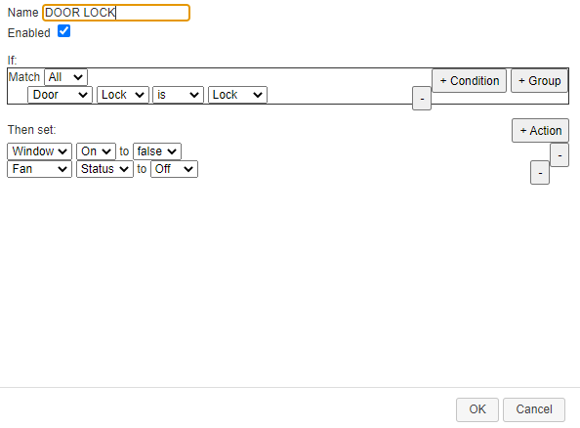

**Step 10 :-** Go Back to Home Page , Click on Door a dropdown will appear:-

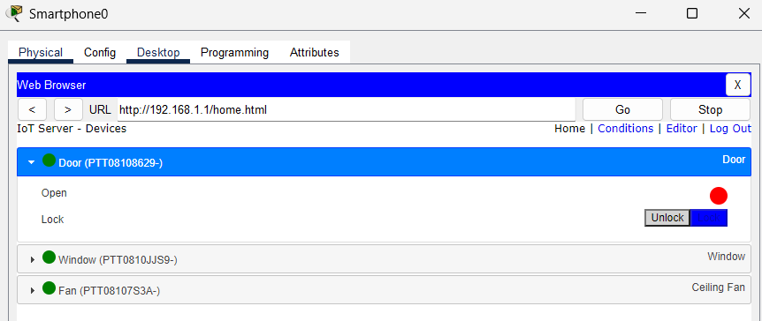

Since the door is set to unlock by default, so lock the door ; click on Lock button, this will close the window and turn off the fan :-

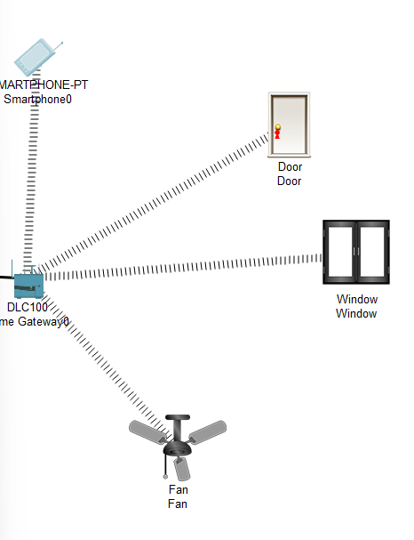

If you click on Unlock button , it will turn on the fan and set it to high and window will get opened :-

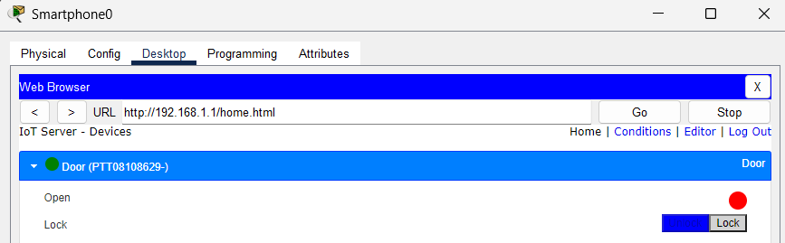

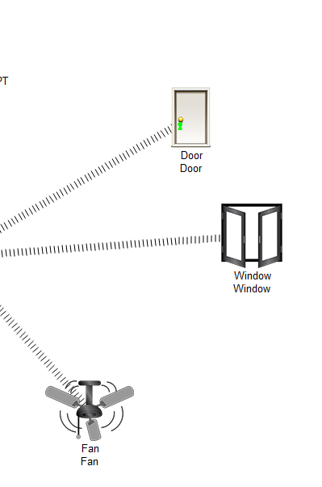

**Practical-10-Implementation**

**Step 1 :-** Setup the below configuration :-  
  
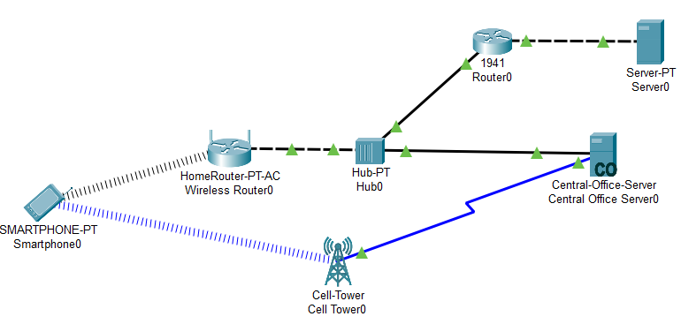

* Connect **Cell-Tower** with **Central-Office-Server** using coaxial cable from **Coaxial0 port** of Cell-Tower to **Coaxial0/0 port** of Central-Office-Server
* Connect **Central-Office-Server** with **Hub** using copper straight-through wire from **Backbone** of Central-Office-Server to **FastEthernet0 port** of Hub.
* Connect **Wireless Router0** with **Hub** using copper cross-over wire from **GigabitEthernet 1 port** of Wireless Router0 to **FastEthernet1 port** of Hub.
* Connect **Hub** with **Router0** using copper straight-through wire from **FastEthernet2 port** of Hub to **GigabitEthernet0/0 port** of Router0.
* Connect **Router0** with **Server0** using copper cross-over wire from **GigabitEthernet0/1 port** of Router0 to **FastEthernet0 port** of Server0.

**Step 2 :-** Configure IP addresses of each following devices :-

|  |  |
| --- | --- |
| **Device** | **IP Address** |
| Smartphone0 | IP Address :- 10.0.0.3 |
| Default Gateway :- 10.0.0.1 |
| Wireless Router0 | IP Address :- 10.0.0.2 |
| Default Gateway :- 10.0.0.1 |
| Router0 | GigabitEthernet0/0 :- 10.0.0.1 |
| GigabitEthernet0/1 :- 20.0.0.1 |
| Server0 | IP Address :- 20.0.0.2 |
| Default Gateway :- 20.0.0.1 |

Diagrammatically we can show configuration of above devices :-

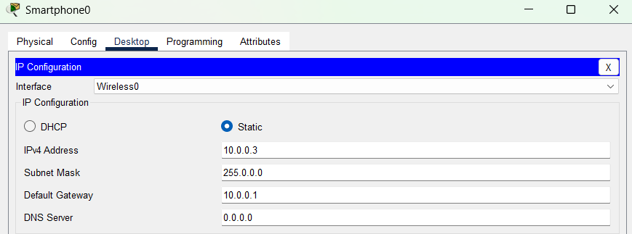

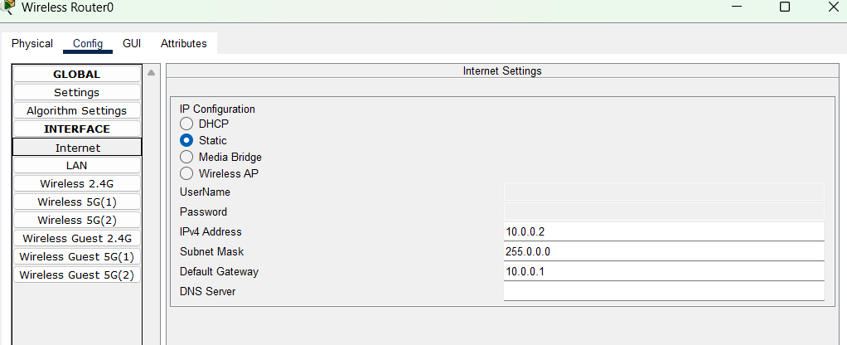

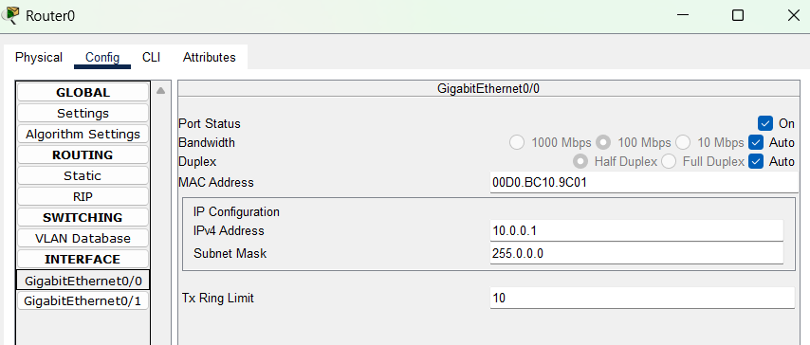

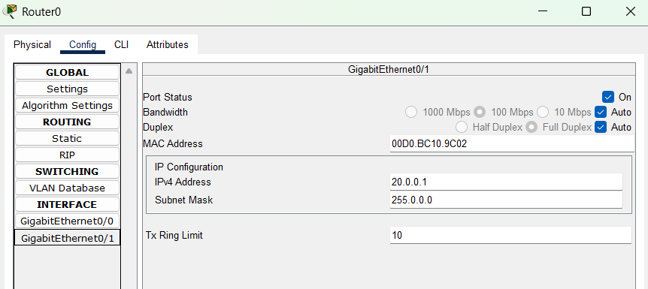

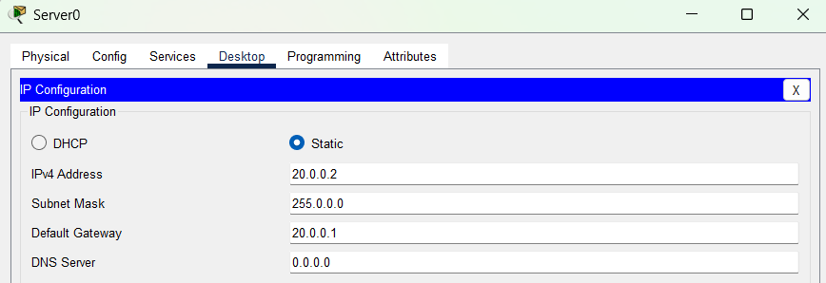

**Step 3 :-** Now click on Smartphone0 and navigate to Desktop > Command Prompt.

Send a message to Server0 by using ping command :-

**ping 20.0.0.2**

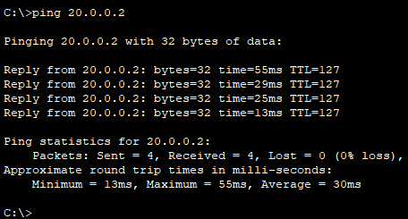

**Step 4 :-** Close the Command Prompt and go to Web Browser , We check whether we receive response message from server , Type 20.0.0.2 in URL field and click on **Go** :-

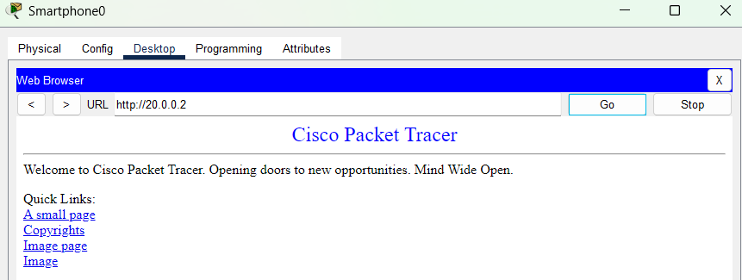

**Step 5 :-** Click on **small page :-**

**Step 6 :-** You’ll get the response from the server.

